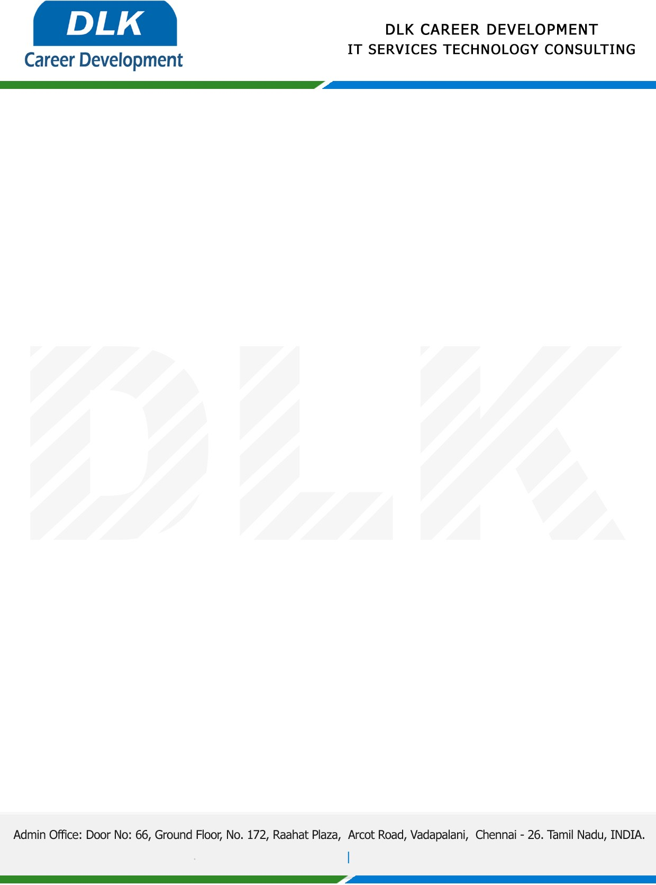

Date: 02/February/ 2023

**To**

Department of MCA(Computer Application) [,](https://www.cseindia.org/)

Head of Department,

Dwaraka Doss Goverdhan Doss Vaishnav College, Chennai -  600106.

**Sub: Letter of Project Acceptance**

This is to certify that **MS LOKHASREE S (REG NO: 2113092037151)** final year student of has accepted the Project Work duration from **February 2023 to May 2023**under the domain **“Java”.** During the Project, all information and data collected from you should be kept confidential.

**Topic:** Health Analysis and Recommendation Based on Food using Data Mining.

We appreciate your interest in **DLK CAREER DEVELOPMENT**

